Appendix VI
Draft resource stock status summary – Bigeye Tuna

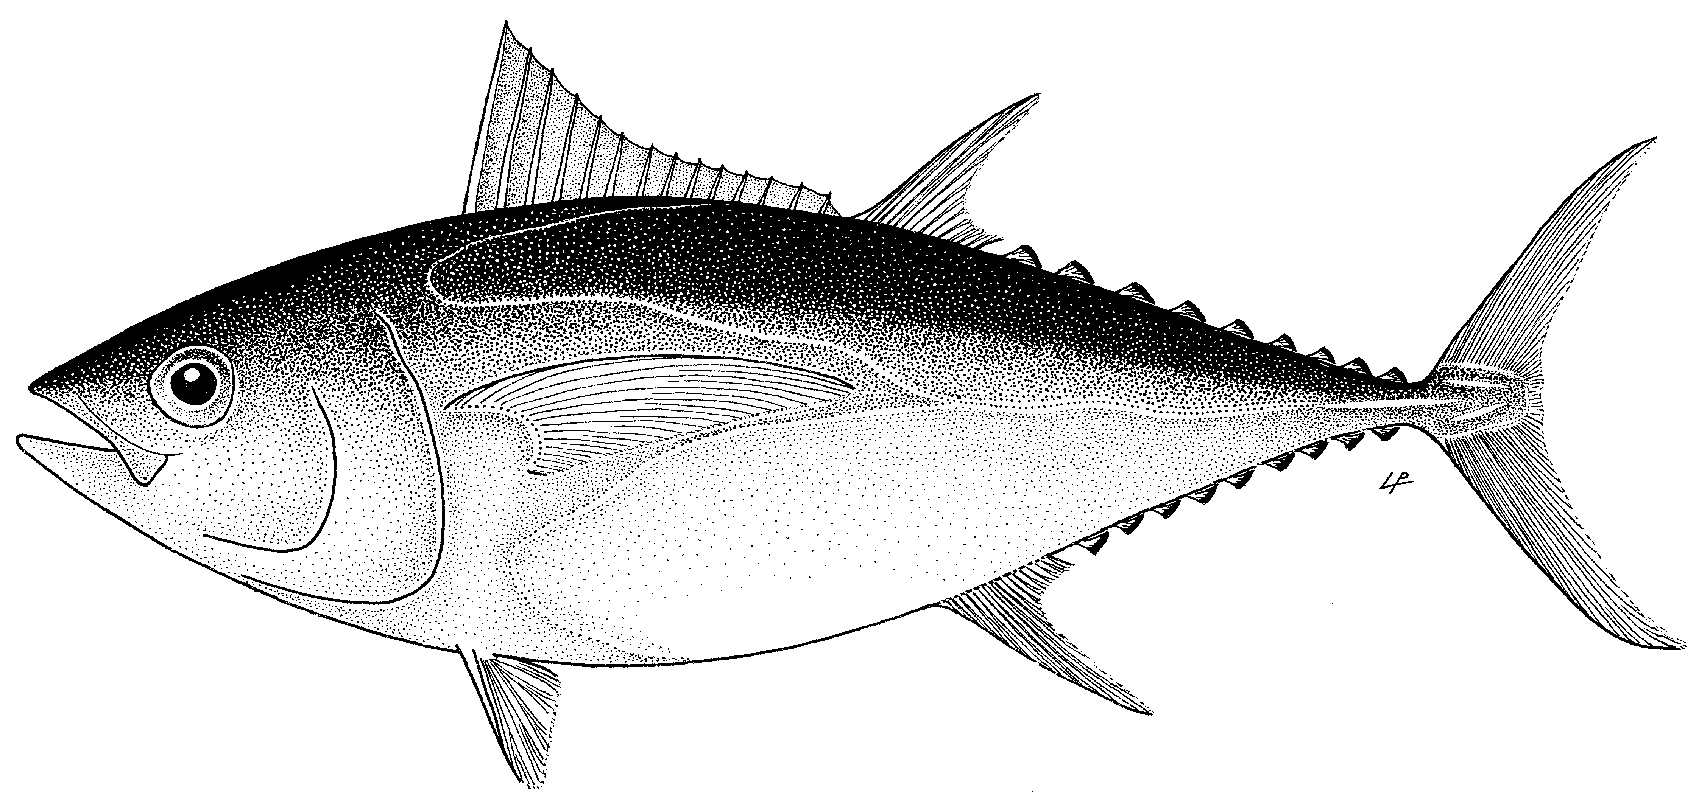

Status of the Indian Ocean bigeye tuna (BET: Thunnus obesus) resource

TABLE 1. Bigeye tuna: Status of bigeye tuna (Thunnus obesus) in the Indian Ocean.
Area¹ | Indicators |  | 2018 stock status³ determination
Indian Ocean | Catch in 2017²:  Average catch 2013–2017: | 90,050 t  95,997 t | 83.7%*
 | MSY (1,000 t) (80% CI):  F_{MSY} (80% CI):  SB_{MSY} (1,000 t) (80% CI):  F_{2015/}F_{MSY} (80% CI):  SB_{2015/}SB_{MSY} (80% CI):  SB₂₀₁₅/SB₀ (80% CI): | 104 (87-121)  0.17 (0.14-0.20)  525 (364-718)  0.76 (0.49-1.03)  1.29 (1.07-1.51)  0.38 (n.a. – n.a.)
¹ Boundaries for the Indian Ocean stock assessment are defined as the IOTC area of competence.
² Proportion of catch estimated or partially estimated by IOTC Secretariat for catches in 2017: 21%
³ The stock status refers to the most recent years’ data used in the last assessment conducted in 2016.
* Estimated probability that the stock is in the respective quadrant of the Kobe plot (shown below), derived from the confidence intervals associated with the current stock status. The confidence intervals for SB₂₀₁₅/SB₀ were not estimated for the models used.

Colour key | Stock overfished (SB_{year}/SB_{MSY}< 1) | Stock not overfished (SB_{year}/SB_{MSY}≥ 1)
Stock subject to overfishing(F_{year}/F_{MSY}> 1) | 2.1% | 13.8%
Stock not subject to overfishing (F_{year}/F_{MSY}≤ 1) | 0.4% | 83.7%
Not assessed/Uncertain

Indian Ocean Stock – Management Advice
Stock status. No new stock assessment was carried out for bigeye tuna in 2018, thus, stock status is determined on the basis of the 2016 assessment and other indicators presented in 2018. In 2016, six models were applied to the bigeye tuna stock in the IOTC area of competence (ASAP, BDM, ASPIC, SCAA, BSPM and SS3). The reported stock status is based on the SS3 model formulation using a grid designed to capture the uncertainty on stock recruitment relationship and the influence of tagging information. Spawning stock biomass in 2015 was estimated to be 38% of the unfished levels (Table 1) and 129% (107–151%) of the level that can support MSY. The assessment is qualitatively similar to the stock assessment conducted in 2013 but with a lower relative biomass (from 144 to 129% SB/SB_{MSY}) and higher relative fishing mortality (from 42 to 76% F/F_{MSY}). Considering the quantified uncertainty, which is conservative, the assessment indicates that, with high likelihood, SB₂₀₁₅ is above SB_{MSY} and F₂₀₁₅ is below F_{MSY}. The median value of MSY from the model runs presented with SS3 was 104,000 t with a range between 87,000 and 121,000 t (a median level 22% lower than the estimate in 2013). Catches in 2017 (≈90,050 t) remain lower than the estimated MSY values from the stock assessment conducted in 2016. The average catch over the previous five years (2013–17; ≈95,997 t) also remains below the estimated MSY. Thus, on the weight-of-evidence available in 2018, the bigeye tuna stock is determined to be not overfished and is not subject to overfishing (Table 1).

Outlook. Declines in longline effort since 2007, particularly from the Japanese, Taiwanese and Rep. of Korea longline fleets have lowered the pressure on the Indian Ocean bigeye tuna stock, indicating that current fishing mortality would not reduce the population to an overfished state in the near future. The Kobe strategy matrix based on the plausible model runs from SS3 in 2016 illustrates the levels of quantified risk associated with varying catch levels over time and could be used to inform future management actions (Table 2). The SS3 projections from the 2016 assessment show that there is a low risk of exceeding MSY-based reference points by 2018, and 2025 if catches are maintained at a level of 90,500 t (2017 catches) (Table 2).

Management advice. The stock status determination did not qualitatively change in 2018. If catches remain below the estimated MSY levels estimated for the current mix of fisheries, then immediate management measures are not required. However, increased catch or increases in the mortality on immature fish will likely increase the probabilities of breaching reference levels in the future. Continued monitoring and improvement in data collection, reporting and analysis is required to reduce the uncertainty in assessments (Table 2).

The following key points should also be noted:
- Maximum Sustainable Yield (MSY): estimate for the Indian Ocean stock is 104,101 t with a range between 87,000–121,000 t for SS3 (Table 1). The average 2013-2017 catches of ≈95,997 t, and catches for each year since 2009 were below the MSY level.
- Interim reference points: Noting that the Commission in 2015 agreed to Resolution 15/10 on target and limit reference points and a decision framework, the following should be noted:
  - Fishing mortality: Current fishing mortality is considered to be at 76% of the interim target reference point of FMSY, and 54% of the interim limit reference point of 1.3*FMSY (Fig. 2).
  - Biomass: Current spawning biomass is considered to at 129% of the interim target reference point of SBMSY and well above the interim limit reference point of 0.5*SBMSY (Fig. 2).
- Main fishing gear (Average catch 2013–17): Longline ≈48%; Purse seine ≈26% (FAD associated school (LS) ≈19%; free swimming school (PS) ≈7%); All other (artisanal) gears ≈26% (Fig 1).
- Main fleets (Average catch 2013–17): Indonesia ≈27%; Taiwan,China ≈18%; European Union ≈17% (EU-Spain: ≈12%; EU-France: ≈5%); Seychelles ≈13%.

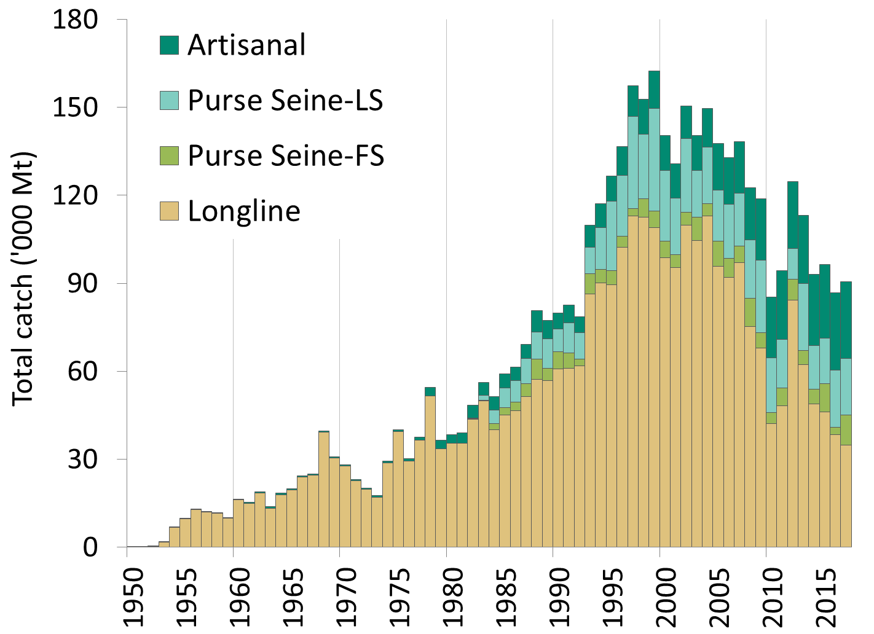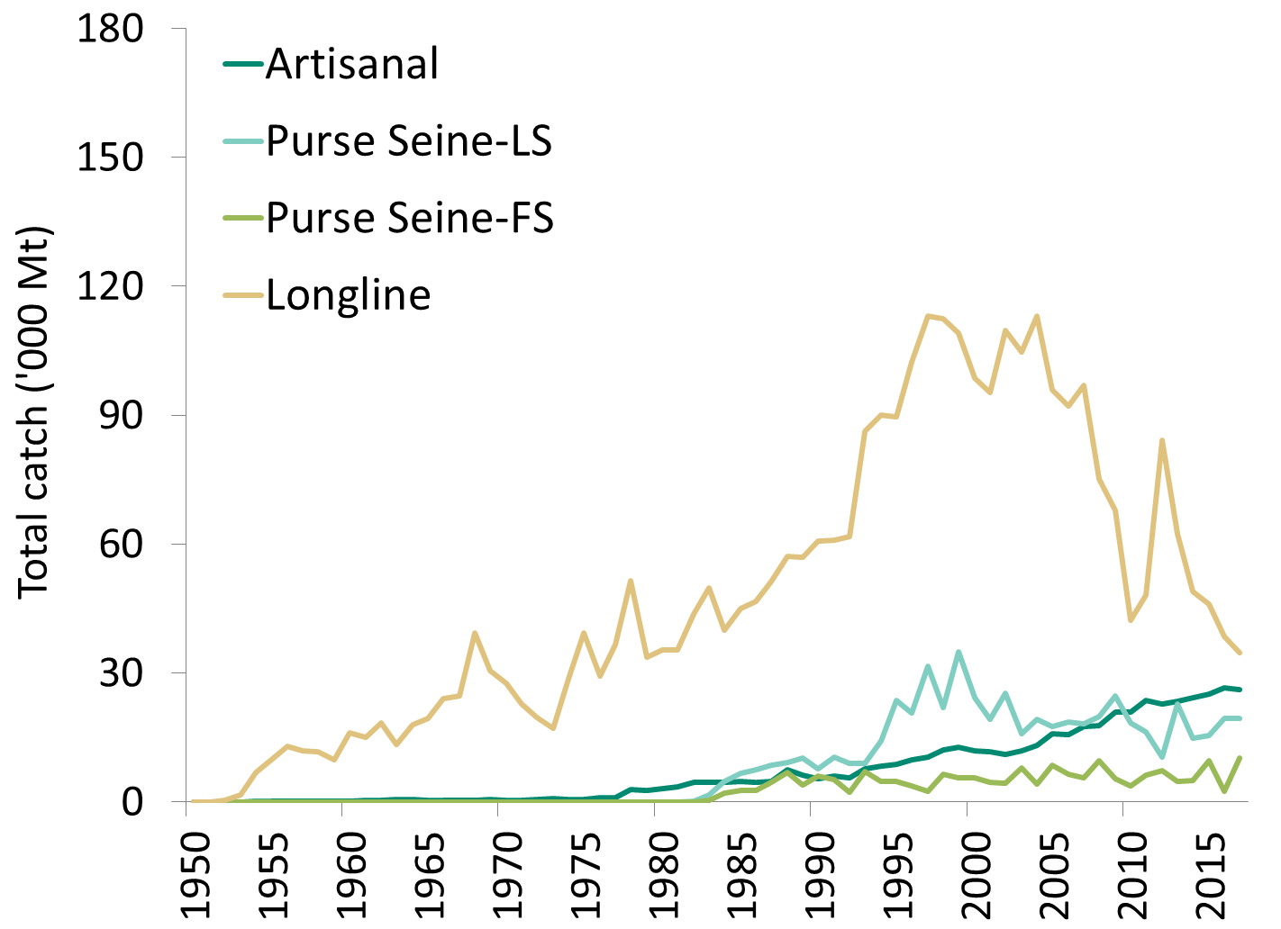
Fig. 1(a-b). Annual catches of bigeye tuna by gear (1950–2017). Data as of September 2018.

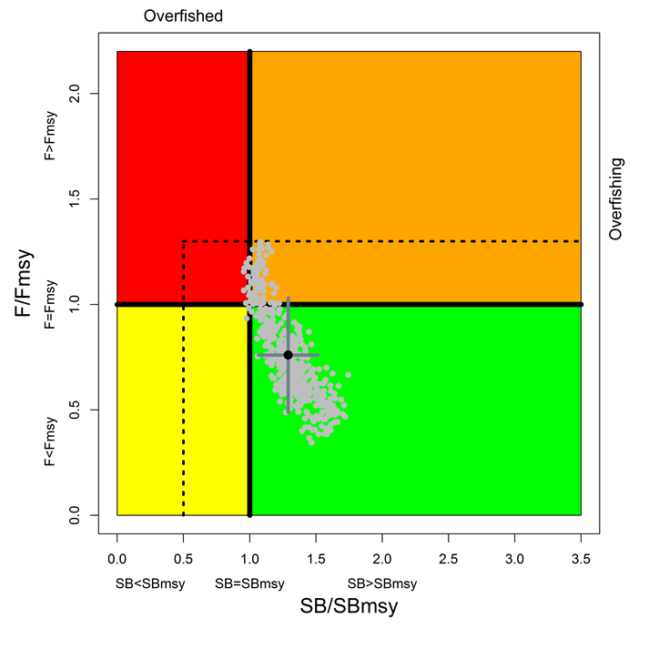
Fig. 2. Bigeye tuna: SS3 Aggregated Indian Ocean assessment Kobe plot. Dotted black lines are the interim limit reference points adopted by the Commission via Resolution 15/10. The grey points represent 500 estimates of 2015 stock status from the six SS3 scenarios. The black point represents the average of the six SS3 scenarios with associated 80% confidence interval.

TABLE 2. Bigeye tuna: Stock Synthesis base case Indian Ocean assessment Kobe II Strategy Matrix. Probability (percentage) of violating the MSY-based target (top) and limit (bottom) reference points for constant catch projections (relative to catches from 2015* (93,040t), ± 20%, + 40% ) projected for 3 and 10 years.
Reference point and projection timeframe | Alternative catch projections (relative to the catch level from 2015*) and weighted probability (%) scenarios that violate MSY-based target reference point
 | 80%  (74,432t) | 100%  (93,040t) | 120%  (111,648t) | 140%  (130,256t)
B₂₀₁₈ < B_{MSY} | 11 | 20 | 30 | 40
F₂₀₁₈ > F_{MSY} | 2 | 19 | 40 | 61
B₂₀₂₅ < B_{MSY} | 6 | 25 | 49 | 60
F₂₀₂₅ > F_{MSY} | 1 | 19 | 42 | 53
Reference point and projection timeframe | Alternative catch projections (relative to the catch level from 2015*) and probability (%) of violating MSY-based limit reference points  (B_{lim} = 0.5 B_{MSY}; F_{Lim} = 1.3 F_{MSY})
 | 80%  (74,432t) | 100%  (93,040t) | 120%  (111,648t) | 140%  (130,256t)
B₂₀₁₈ < B_{LIM} | 0 | 0 | 0 | 0
F₂₀₁₈ > F_{LIM} | 0 | 4 | 18 | 37
B₂₀₂₅ < B_{LIM} | 0 | 1 | 12 | 33
F₂₀₂₅ > F_{LIM} | 0 | 9 | 30 | 48
* Catches for 2015 at the time of the last bigeye tuna assessment conducted in 2016.

