Appendix X  
[ Draft ] resource stock status summary – Indo-Pacific sailfish



**Status of the Indian Ocean Indo-Pacific sailfish (SFA: *Istiophorus platypterus*) resource**

**TABLE 1**. Indo-Pacific sailfish: Status of Indo-Pacific sailfish (*Istiophorus platypterus*) in the Indian Ocean.

|  |  |  |  |
| --- | --- | --- | --- |
| **Area1** | **Indicators** | | **2018 stock status determination** |
| Indian Ocean | Catch 20172:  Average catch 2013-2017: | 33,2803 t  29,8733 t |  |
| MSY (1,000 t) (80% CI):  FMSY (80% CI):  BMSY (1,000 t) (80% CI):  Fcurrent/FMSY (80% CI):  Bcurrent/BMSY (80% CI):  Bcurrent/B0 (80% CI): | 25.00 (16.18–35.17)  0.26 (0.15–0.39)  87.52 (56.30–121.02)  1.05 (0.63–1.63)  1.13 (0.87–1.37)  0.56 (0.44–0.67) |

1 Boundaries for the Indian Ocean = IOTC area of competence.

2 Proportion of catches estimated or partially estimated by IOTC Secretariat in 2018: 52%.

3 Source: Nominal catches (IOTC-2018-WPB16-DATA03b).

|  |  |  |
| --- | --- | --- |
| **Colour key** | Stock overfished(Byear/BMSY< 1) | Stock not overfished (Byear/BMSY≥ 1) |
| Stock subject to overfishing(Fyear/FMSY> 1) |  |  |
| Stock not subject to overfishing (Fyear/FMSY≤ 1) |  |  |
| Not assessed/Uncertain |  | |

**Indian Ocean stock – Management Advice**

***Stock status.*** No new stock assessment was carried out for Indo-Pacific sailfish in 2018, thus, the stock status is determined on the basis of the 2015 assessment and other indicators presented in 2018. In 2015, data poor methods for stock assessment using Stock Reduction Analysis (SRA) techniques indicated that the stock is not yet overfished, but is subject to overfishing (**Table 1**). In addition, a Bayesian Surplus Production Model indicated that the stock could be severely overfished so this is a less pessimistic outlook on the stock status. The stock appears to show a continued increase catches which is a cause of concern (**Fig. 1**), indicating that fishing mortality levels may be becoming too high (**Fig. 2**). Aspects of the biology, productivity and fisheries for this species combined with the data poor status on which to base a more formal assessment are also a cause for concern. Research emphasis on further developing possible CPUE indicators from gillnet fisheries, and further exploration of stock assessment approaches for data poor fisheries are warranted. Given the limited data being reported for coastal gillnet fisheries, and the importance of sports fisheries for this species, efforts must be made to rectify these information gaps. The lack of catch records in the Persian Gulf should also be examined to evaluate the degree of localised depletion in Indian Ocean coastal areas. On the weight-of-evidence available in 2018, the stock is determined to be still **not overfished** but **subject to overfishing**.

***Outlook.*** The estimated increase in coastal gillnet catch and effort in recent years is a substantial cause for concern for the Indian Ocean stock, however there is not sufficient information to evaluate the effect this will have on the resource. It is also noted that 2017 catches (34,891 t) exceed the catch limit prescribed in Resolution 18/05 (25,000 t).

***Management advice.*** Resolution 18/05 prescribes a catch limit of 25,000t which is based on the management advice provided in 2017 (i.e., catches below MSY).

The following key points should also be noted:

* **Maximum Sustainable Yield (MSY):** estimate for the Indian Ocean stock is 25,000 t.
* **Provisional reference points:** Although the Commission adopted reference points for swordfish in Resolution 15/10 on target and limit reference points and a decision framework, no such interim reference points have been established for I.P. sailfish.
* **Main fishing gear (average catches 2013-17)**: gillnets account for around 70% of total catches in the Indian Ocean, followed by troll and hand lines (21%), with remaining catches recorded under longlines and other gears (Fig. 1).
* **Main fleets (average catches 2013-17):** Three quarters of the total catches of Indo-Pacific sailfish are accounted for by four countries situated in the Arabian Sea: I.R. Iran (gillnets): 31%; India (gillnets and trolling): 19%; Pakistan (gillnets): 16%; and Sri Lanka (gillnets and fresh longline): 9%.

|  |
| --- |
|  |
| **Fig. 1.** Indo-Pacific sailfish: catches by gear and year recorded in the IOTC Database (1950–2017).  ***Notes****: Other gears (OT) includes: longline-gillnet, handline, gillnet, coastal longline, troll line, sport fishing, and all other gears* |

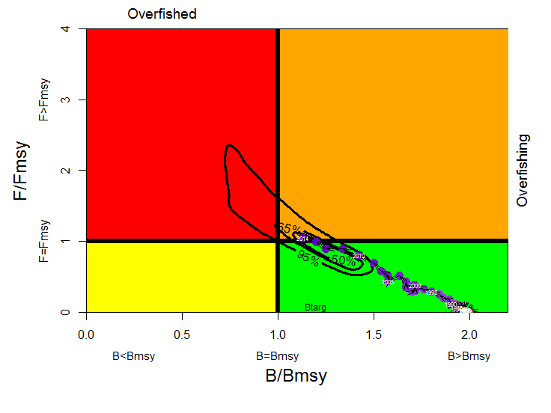

**Fig.2.** Indo-Pacific sailfish: Stock reduction analysis (Catch MSY Method) of aggregated Indian Ocean assessment Kobe plot (contours are the 50, 65 and 90 percentiles of the 2014 estimate). Black lines indicate the trajectory of the point estimates (blue circles) for the B ratio and F ratio for each year 1950–2014.

**Table 2.** Indo-Pacific sailfish: Indian Ocean stock reduction analysis Kobe II Strategy Matrix.Probability (percentage) of violating the MSY-based reference points for nine constant catch projections (relative to the average catch levels from 2012–2014 (29,164 t)*, ± 10%, ± 20%, ± 30% ± 40%) projected for 3 and 10 years.

|  |  |  |  |  |  |  |  |  |  |
| --- | --- | --- | --- | --- | --- | --- | --- | --- | --- |
| **Reference point and projection timeframe** | **Alternative catch projections (relative to the average catch level from 2012–14* (29,164 t)**  **and probability (%) of violating MSY-based reference points** | | | | | | | | |
|  | **60%** | **70%** | **80%** | **90%** | **100%** | **110%** | **120%** | **130%** | **140%** |
|  | 17,498 t | 20,415 t | 23,331 t | 26,248 t | 29,164 t | 32,080 t | 34,997 t | 37,913 t | 40,830 t |
| B2017<BMSY | 10 | 15 | 20 | 25 | 30 | 35 | 41 | 47 | 53 |
| F2017> FMSY | 16 | 27 | 38 | 49 | 61 | 72 | 83 | 94 | 99 |
|  |  |  |  |  |  |  |  |  |  |
| B2024<BMSY | 6 | 16 | 28 | 41 | 55 | 68 | 81 | 91 | 97 |
| F2024> FMSY | 12 | 23 | 36 | 52 | 68 | 84 | 97 | 100 | 100 |

*\* Average catches for 2012-2014 at the time of the last I.P. sailfish assessment conducted in 2015.*