Appendix X
Executive Summary: Longtail Tuna

Status of the Indian Ocean longtail tuna (LOT: Thunnus tonggol) resource

TABLE 1. Longtail tuna: Status of longtail tuna (Thunnus tonggol) in the Indian Ocean.
Area¹ | Indicators |  | 2018 stock status determination
Indian Ocean | Catch 2017²:  Average catch 2013–2017: | 135,006 t  139,856 t | 67%
 | MSY (1,000 t) (*):  F_{MSY} (*):  B_{MSY} (1,000 t) (*):  F₂₀₁₅/F_{MSY} (*):  B₂₀₁₅/B_{MSY} (*):  B₂₀₁₅/B₀ (*): | 140 (103–184)  0.43 (0.28–0.69)  319 (200–623)  1.04 (0.84–1.46)  0.94 (0.68–1.16)  0.48 (0.34–0.59)

¹ Boundaries for the Indian Ocean stock assessment are defined as the IOTC area of competence.
² Proportion of catches estimated or partially estimated by IOTC Secretariat in 2017: 36%

Nominal catches represent those estimated by the IOTC Secretariat. If these data are not reported by CPCs, the IOTC Secretariat estimates total catch from a range of sources including: partial catch and effort data; data in the FAO FishStat database; catches estimated by the IOTC from data collected through port sampling; data published through web pages or other means; data reported by other parties on the activity of vessels; and data collected through sampling at the landing place or at sea by scientific observers.

*Range of plausible values of biologically realistic OCOM model realizations (IOTC-2017-WPNT07-R)

Colour key | Stock overfished(SB_{year}/SB_{MSY}< 1) | Stock not overfished (SB_{year}/SB_{MSY}≥ 1)
Stock subject to overfishing(F_{year}/F_{MSY}> 1) | 67% | 0%
Stock not subject to overfishing (F_{year}/F_{MSY}≤ 1) | 6% | 27%
Not assessed/Uncertain

Indian Ocean stock – Management Advice
Stock status. Analysis using the Optimised Catch-Only Method (OCOM) indicates that the stock is being exploited at a rate that exceeded F_{MSY} in recent years and the stock appears to be below B_{MSY} and above F_{MSY} (67% of plausible models runs) (Fig. 2). Catches were above MSY between 2010 and 2014, however catches have decreased between 2012 and 2016 from ~175,000 to ~128,000 t (Fig. 1) and were below estimated MSY in 2017. The F₂₀₁₅/F_{MSY} ratio is slightly lower than previous estimates, reflecting the decrease in catches reported in the last few years. Nevertheless, the estimate of the B₂₀₁₅ /B_{MSY} ratio (0.94) was also slightly lower than in previous years. An assessment using the revised Catch-MSY method was also undertaken in 2017 and results were consistent with OCOM in terms of status. Therefore, based on the weight-of-evidence currently available, the stock is considered to be both overfished and subject to overfishing (Table 1; Fig. 2).
Outlook. There remains considerable uncertainty about stock structure and the total catches in the Indian Ocean. The increase in annual catches to a peak in 2012 increased the pressure on the longtail tuna Indian Ocean stock, although the catch trend has reversed since then. As noted in 2015, the apparent fidelity of longtail tuna to particular areas/regions is a matter for concern as overfishing in these areas can lead to localised depletion. Research emphasis on collating catch per unit effort (CPUE) time series for the main fleets, size compositions and life trait history parameters (e.g. estimates of growth, natural mortality, maturity, etc.) should be considered a high priority for the Commission.
Management advice. There is a substantial risk of exceeding MSY-based reference points by 2018 if catches are maintained at current (2015) levels (63% risk that B₂₀₁₈<B_{MSY}, and 55% risk that F₂₀₁₈>F_{MSY}) (Table 2). If catches are reduced by 10% this risk is lowered to 33% probability B₂₀₁₈<B_{MSY} and 28% probability F₂₀₁₈>F_{MSY}). If catches are capped at current (2015) levels at the time of the assessment (i.e. 136,849 t), the stock is expected to recover to levels above MSY reference points with at least a 50% probability by 2025. Catches have remained below estimated MSY since 2015.
The following should be also noted:
- The Maximum Sustainable Yield estimate of around 140,000 t was exceeded between 2010 and 2014. Limits to catches are warranted to recover the stock to the B_{MSY} level.
- Limit reference points: The Commission has not adopted limit reference points for any of the neritic tunas under its mandate.
- Further work is needed to improve the reliability of the catch series. Reported catches should be verified or estimated, based on expert knowledge of the history of the various fisheries or through statistical extrapolation methods.
- Improvements in data collection and reporting are required if the stock is to be assessed using integrated stock assessment models.
- Research emphasis on collating catch per unit effort (CPUE) time series for the main fleets (I.R.Iran, Indonesia, Pakistan, India and Oman), size compositions and life trait history parameters (e.g. estimates of growth, natural mortality, maturity, etc.) should be considered a high priority for the Commission.
- There is limited information submitted by CPCs on total catches, catch and effort and size data for neritic tunas, despite their mandatory reporting status. In the case of 2017 catches, 36% of the total catches were either fully or partially estimated by the IOTC Secretariat, which increases the uncertainty of the stock assessments using these data. Therefore the management advice to the Commission includes the need for CPCs to comply with IOTC data requirements per Resolution 15/01 and 15/02.
- Main fishing gear (average catches 2013–17): Longtail tuna are caught mainly using gillnets and, to a lesser extent, coastal purse seine nets and trolling (Fig. 1).
- Main fleets (average catches 2013–17): Over 44% of the catches of longtail in the Indian Ocean are accounted for by I.R. Iran, followed by Indonesia (≈16%), and Oman (≈11%).

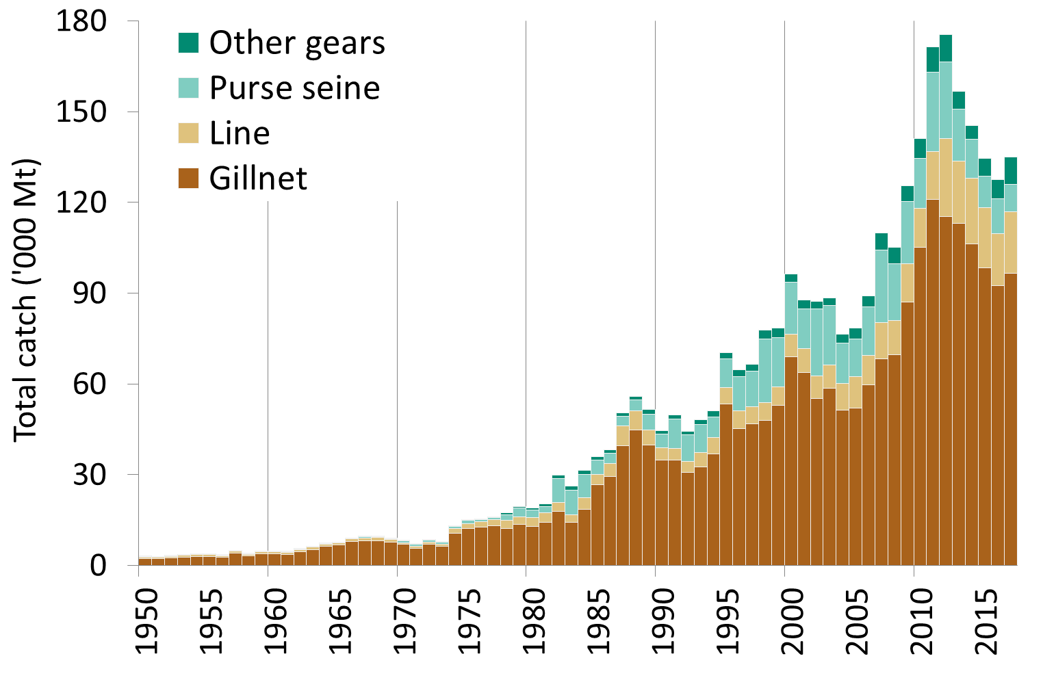
Fig. 1. Longtail tuna: Annual catches by gear recorded in the IOTC Database (1950–2017).

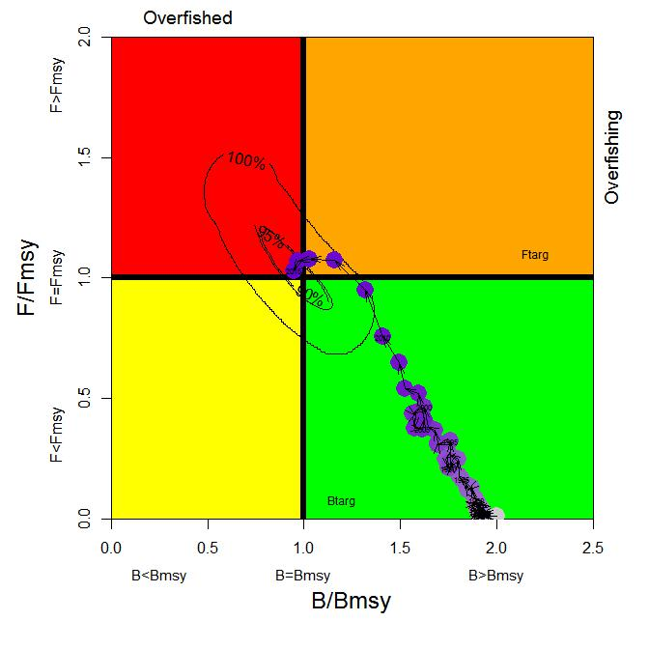
Fig. 2. Longtail tuna. OCOM Indian Ocean assessment Kobe plot. Blue circles indicate the trajectory of the point estimates for the B ratio and F ratio for each year between 1950 and 2015 (the black lines represent all plausible model runs shown around 2015 estimate).

Table 2. Longtail tuna: OCOM aggregated Indian Ocean assessment Kobe II Strategy Matrix. Probability (percentage) of violating the MSY-based reference points for constant catch projections (2015 +20%,+10%, -10%, - 20%, -30% projected for 3 and 10 years). Note: from the 2017 stock assessment using catch estimates (i.e. 1950-2015) at that time.

Reference point and projection timeframe |  | Alternative catch projections (relative to 2015) and weighted probability (%) scenarios that violate MSY-based reference points
 | 70 % |  | 80% | 90% | 100% | 110% | 120%
 | (95,794 t) |  | (109,479 t) | (123,164 t) | (136,849 t) | (150,534 t) | (164,219 t)
B₂₀₁₈ < B_{MSY} | 4 |  | 9 | 33 | 63 | 92 | 99
F₂₀₁₈ > F_{MSY} | 2 |  | 7 | 28 | 55 | 86 | 98
B₂₀₂₅ < B_{MSY} | 0 |  | 0 | 1 | 48 | 100 | 100
F₂₀₂₅ > F_{MSY} | 0 |  | 0 | 1 | 41 | 100 | 100

Definition of fishery: Gillnet: gillnet, including offshore gillnet; Line: coastal longline, hand line, troll line; Purse seine: coastal purse seine, purse seine, ring net; Other gears: baitboat, danish seine, liftnet, longline, longline fresh, trawling.

