Appendix VI  
[ Draft ] resource stock status summary – Swordfish

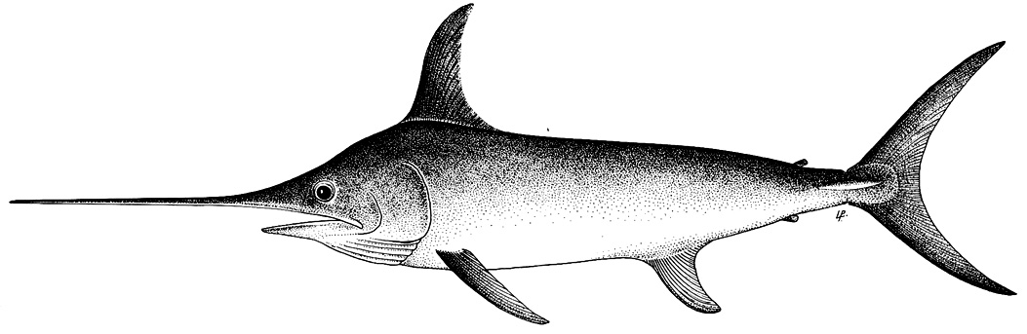

**Status of the Indian Ocean swordfish (SWO: *Xiphias gladius*) resource**

**TABLE 1.** Swordfish: Status of swordfish (*Xiphias gladius*) in the Indian Ocean.

|  |  |  |  |
| --- | --- | --- | --- |
| **Area1** | **Indicators** | | **2018 stock status determination** |
| Indian Ocean | Catch 20172:  Average catch 2013-2017: | 34,7823 (53,6584) t  31,4053 (42,1874) t |  |
| MSY (1,000 t) (80% CI):  FMSY (80% CI):  SBMSY (1,000 t) (80% CI):  F2015/FMSY (80% CI):  SB2015/SBMSY (80% CI):  SB2015/SB1950 (80% CI): | 31.59 (26.30–45.50)  0.17 (0.12–0.23)  43.69 (25.27–67.92)  0.76 (0.41–1.04)  1.50 (1.05–2.45)  0.31 (0.26–0.43) |

1 Boundaries for the Indian Ocean stock assessment are defined as the IOTC area of competence.

2 Proportion of catch estimated or partially estimated by IOTC Secretariat in 2018: 48%.

3 Low-case catch scenario (IOTC-2018-WPB16-DATA03b): alternative catch series incorporating changes to IOTC Secretariat’s methodology for estimating for Indonesia’s fresh tuna longline catches.

4 High-case catch scenario (IOTC-2018-WPB16-DATA03a): includes IOTC Secretariat catch estimates for Indonesian fresh tuna longliners derived from a proxy fleet (i.e., Taiwan,China fresh tuna longliners).

|  |  |  |
| --- | --- | --- |
| **Colour key** | Stock overfished (SByear/SBMSY< 1) | Stock not overfished (SByear/SBMSY≥ 1) |
| Stock subject to overfishing(Fyear/FMSY> 1) |  |  |
| Stock not subject to overfishing (Fyear/FMSY≤ 1) |  |  |
| Not assessed/Uncertain |  | |

**Indian Ocean stock – Management Advice**

***Stock status.*** No new stock assessment was carried out for swordfish in 2018, thus, the stock status is determined on the basis of the 2017 assessment and other indicators presented in 2018.In 2017 a stock synthesis assessment was conducted, with fisheries catch data up to 2015. The assessment uses a spatially disaggregated, sex explicit and age structured model. The SS3 model, used for stock status advice, indicated that MSY-based reference points were not exceeded for the Indian Ocean population (F2015/FMSY< 1; SB2015/SBMSY> 1). Most other models applied to swordfish also indicated that the stock was above a biomass level that would produce MSY. Spawning stock biomass in 2015 was estimated to be 26%–43% of the unfished levels.

There are some uncertainties in the catch estimates from the Indonesian fresh tuna longline (**Fig. 1b**); an alternative catch history was used in the base case stock assessment (**Fig. 1a**). Most recent catches are at the MSY level (31,590 t). On the weight-of-evidence available in 2018, the stock is determined to be ***not overfished*** and ***not subject to overfishing***.

***Outlook.*** The decrease in longline catch and effort from 2005 to 2011 lowered the pressure on the Indian Ocean stock, and despite the recent increase in total recorded catches, current fishing mortality is not expected to reduce the population to an overfished state over the next decade. There is a very low risk of exceeding MSY-based reference points by 2026 if catches are maintained at 2015 levels (<1% risk that SB2026< SBMSY, and <1% risk that F2026> FMSY) (Table 2).

***Management advice*.** The most recent catches (31,407 t in 2016) are at the MSY level (31,590 t). However, given the uncertainty of most recent catches from Indonesian fresh tuna longline fisheries there is a possibility that total catches could already be 39,777 t. The catches should not be increased beyond the MSY level (31,590 t).

The following key points should also be noted:

* **Maximum Sustainable Yield (MSY)**: estimate for the Indian Ocean is 31,590 t.
* **Provisional reference points**: Noting that the Commission in 2015 agreed to Resolution 15/10 *on target and limit reference points and a decision framework*, the following should be noted:
  1. **Fishing mortality**: Current fishing mortality is considered to be below the provisional target reference point of FMSY and below the provisional limit reference point of 1.4*FMSY (**Fig. 2**).
  2. **Biomass**: Current spawning biomass is considered to be above the target reference point of SBMSY, and therefore above the limit reference point of 0.4*SBMSY (**Fig. 2**).
* **Main fishing gear (average catches 2013-17)**: Longline catches are currently estimated to comprise approximately 75% of total swordfish catches in the Indian Ocean (or 69% according to the alternative low-case catch scenario) (Figs. 1a-b).
* **Main fleets (average catches 2013-17):**

(High-case catch scenario):Indonesia (fresh longline): 32%; Taiwan,China (longline): 16%; Sri Lanka (longline-gillnet): 14%; EU,Spain (swordfish targeted longline): 9%.

(Low-case catch scenario): Taiwan,China (longline): 21%; Sri Lanka (longline-gillnet): 18%; EU,Spain (swordfish targeted longline): 12%**;** Indonesia (fresh longline): 9%.

|  |  |  |  |
| --- | --- | --- | --- |
| |  |  |  | | --- | --- | --- | | |  |  | | --- | --- | | (a.) High-case catch scenario | (b.) Low-case catch scenario | |   **Fig. 1a-b.** Swordfish catches by gear and year recorded in the IOTC database (1950–2017):   * (Left): High-case catch scenario (IOTC-2018-WPB16-DATA03a): includes IOTC Secretariat revised catch estimates for Indonesian fresh tuna. * (Right): Low-case catch scenario (IOTC-2018-WPB16-DATA03b): alternative catch series incorporating changes to IOTC Secretariat’s methodology for estimating for Indonesia’s fresh tuna longline catches;   ***Note****: Other gears (OT) includes: longline-gillnet, handline, gillnet, coastal longline, troll line, sport fishing, and all other gears.* |



**Fig. 2.** Swordfish: SS3 Aggregated Indian Ocean assessment Kobe plot (contours are the 50, 60, 70, 80 and 90 percentiles of the 2015 estimate). Blue circles indicate the trajectory of the point estimates for the SB ratio and F ratio for each year 1950–2015. Interim target (Ftarg and SBtarg) and limit (Flim and SBlim) reference points, as set by the Commission, are shown.

**TABLE 2.** Swordfish: SS3 aggregated Indian Ocean assessment Kobe II Strategy Matrix. Probability (percentage) of violating the MSY-based target (top) and limit (bottom) reference points for nine constant catch projections relative to 2015* catch level (32,129 t), ± 10%, ± 20%, ± 30% ± 40%) projected for 3 and 10 years.

|  |  |  |  |  |  |  |  |  |  |
| --- | --- | --- | --- | --- | --- | --- | --- | --- | --- |
| **Reference point and projection timeframe** | **Alternative catch projections (relative to the average catch level from 2015* (32,129 t) and probability (%)**  **of violating MSY-based target reference points (SBtarg = SBMSY; Ftarg = FMSY)** | | | | | | | | |
|  | **60%**  (19,278 t) | **70%**  (22,491 t) | **80%**  (22,704 t) | **90%**  (28,917 t) | **100%**  (32,129 t) | **110%**  (35,343 t) | **120%**  (38,556 t) | **130%**  (41,769 t) | **140%**  (44,982 t) |
| SB2018 < SBMSY | 0 | 0 | 0 | 0 | 0 | 0 | 0 | 8 | 13 |
| F2018 > FMSY | 0 | 0 | 0 | 0 | 13 | 33 | 42 | 58 | 71 |
|  |  |  |  |  |  |  |  |  |  |
| SB2025 < SBMSY | 0 | 0 | 0 | 0 | 8 | 33 | 46 | 63 | 75 |
| F2025 > FMSY | 0 | 0 | 0 | 4 | 38 | 54 | 71 | 83 | 88 |
| **Reference point and projection timeframe** | **Alternative catch projections (relative to the average catch level from 2015* (32,129 t) and probability (%)**  **of violating MSY-based limit reference points (SBlim = 0.4 SBMSY; FLim = 1.4 FMSY)** | | | | | | | | |
|  | **60%**  (19,278 t) | **70%**  (22,491 t) | **80%**  (22,704 t) | **90%**  (28,917 t) | **100%**  (32,129 t) | **110%**  (35,343 t) | **120%**  (38,556 t) | **130%**  (41,769 t) | **140%**  (44,982 t) |
| SB2018 < SBLim | 0 | 0 | 0 | 0 | 0 | 0 | 0 | 0 | 0 |
| F2018 > FLim | 0 | 0 | 0 | 0 | 0 | 0 | 0 | 13 | 33 |
|  |  |  |  |  |  |  |  |  |  |
| SB2025 < SBLim | 0 | 0 | 0 | 0 | 0 | 0 | 0 | 0 | 21 |
| F2025 > FLim | 0 | 0 | 0 | 0 | 0 | 21 | 42 | 63 | 75 |

*\* 2015 catches, at the time of the last swordfish assessment conducted in 2017.*