**Executive Summary: Black marlin**



**Status of the Indian Ocean black marlin (BLM: *Makaira indica*) resource**

**TABLE 1.** Black marlin:Status of black marlin(*Makaira indica*) in the Indian Ocean.

|  |  |  |  |
| --- | --- | --- | --- |
| **Area1** | **Indicators** | | **2016**  **stock status determination** |
| Indian Ocean | Catch 20162:  Average catch 2012–2016: | 17,829 t  16,638 t | **80%\*** |
| MSY (1,000 t) (80% CI):  FMSY (80% CI):  BMSY (1,000 t) (80% CI):  F2015/FMSY (80% CI):  B2015/BMSY (80% CI):  B2015/B1950 (80% CI): | 9.932 (6.963-12.153)  0.211 (0.089-0.430)  47.430 (27.435-100.109)  2.42 (1.52-4.06)  0.81 (0.55-1.10)  0.30 (0.20-0.41) |

1Boundaries for the Indian Ocean = IOTC area of competence;

2Proportion of catch estimated or partially estimated by IOTC Secretariat in 2016: 42%

* Estimated probability that the stock is in the respective quadrant of the Kobe plot (shown below), derived from the confidence intervals associated with the current stock status.

|  |  |  |
| --- | --- | --- |
| **Colour key** | Stock overfished(Byear/BMSY< 1) | Stock not overfished (Byear/BMSY≥ 1) |
| Stock subject to overfishing(Fyear/FMSY> 1) | 80% | 19% |
| Stock not subject to overfishing (Fyear/FMSY≤ 1) | 0% | 1% |
| Not assessed/Uncertain |  | |

**Indian Ocean stock – Management Advice**

***Stock status.*** Stock status based on BSP-SS stock assessment suggests that the stock in 2015 is in the red zone in the Kobe plot with F/FMSY=2.42 and B/BMSY=0.81. Another approach by ASPIC examined in 2016 came to similar conclusions. The Kobe plot (Fig. 2) from the BSP-SS model indicated that the stock has been **subject to overfishing** and **overfished** in recent years (Table 1; Fig. 2).

***Outlook.*** The uncertainty in the data available for assessment purposes and the CPUE series suggests that the advice should be interpreted with caution. The recent sharp increase of catch changed the status of stock to the red zone of the Kobe plot. Even if the catch levels are reduced by 40% of the average 2013-2015 levels, it is unlikely that biomass would be above the BMSY and F would be below the FMSY in the next 10 years (Table 2).

***Management advice.*** The current catches of BLM (Fig. 1) are considerably higher than MSY (9,932 t) and the stock is overfished (B2015< BMSY and currently subject to overfishing (F2015> FMSY). Even with a 40% reduction in current catches, it is very unlikely (less than 5%) to achieve the Commission objectives of being in the green zone of the Kobe Plot by 2025. Current catch levels are not sustainable and there is a need for urgent actions to decrease these catch levels. **The SC recommends that the maximum catch limit should be lower than MSY (9,932t).**

The following key points should be noted:

* **Maximum Sustainable Yield (MSY)**: estimate for the whole Indian Ocean is 9,932 t.
* **Provisional reference points**: Although the Commission adopted reference points for swordfish in Resolution 15/10 *on target and limit reference points and a decision framework*, no such interim reference points nor harvest control rules have been established for black marlin.

|  |
| --- |
|  |
| **Fig. 1.** Black marlin: catches by gear and year recorded in the IOTC Database (1950–2016). *Note: Other gears includes: coastal purse seine, Danish purse seine, beach seine and purse seine.* |

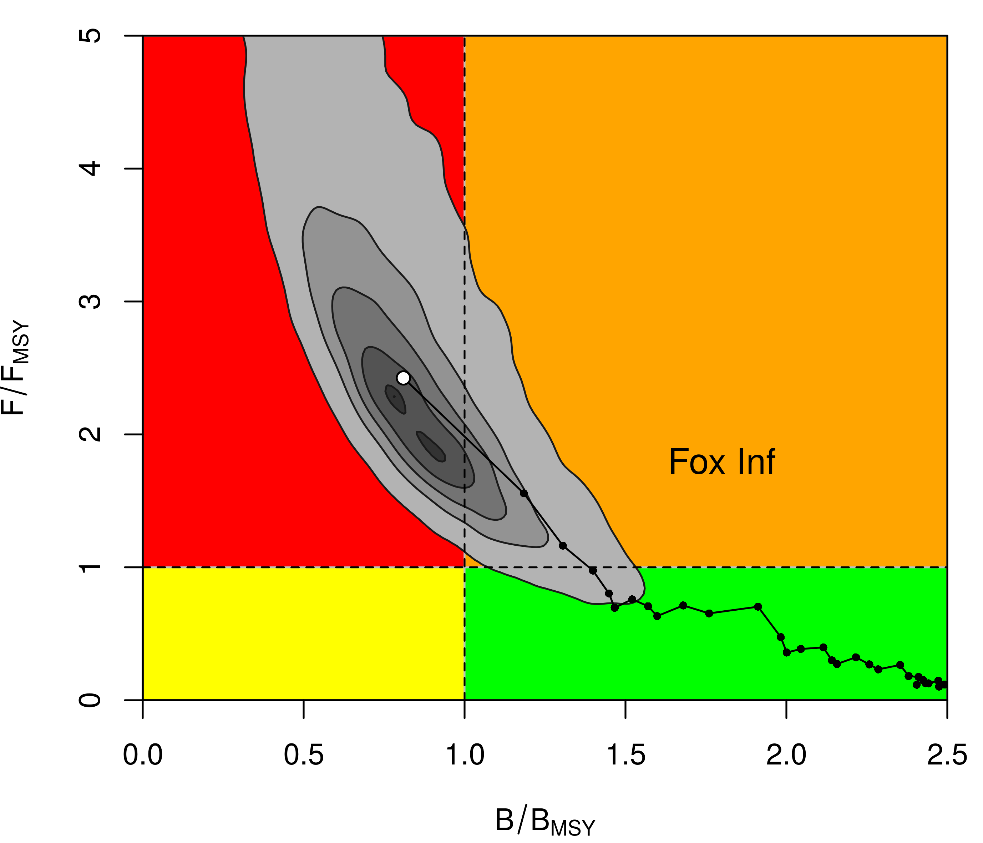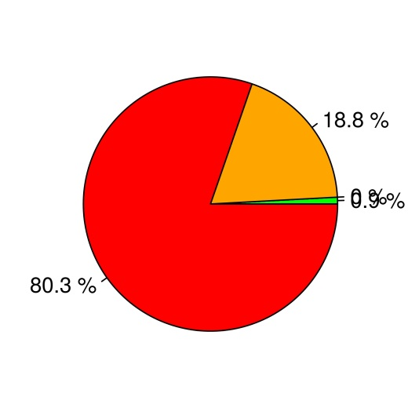

**Fig. 2**. Black marlin: BSP-SS aggregated Indian Ocean assessment Kobe plots for black marlin (contours are the 25, 50, 75 and 90 percentiles of the 2015 estimate). Black line indicates the trajectory of the point estimates (blue circles) for the spawning biomass (B) ratio and F ratio for each year 1950–2015.

**Table 2.** Black Marlin: Indian Ocean BSP-SS Kobe II Strategy Matrix.Probability (percentage) of violating the MSY-based target reference points for nine constant catch projections (catch level 17,171 t, ± 10%, ± 20%, ± 30% ± 40%) projected for 3 and 10 years.

|  |  |  |  |  |  |  |  |  |  |  |
| --- | --- | --- | --- | --- | --- | --- | --- | --- | --- | --- |
| **Reference point and projection timeframe** | **Alternative catch projections (relative to the average catch level 17,171 t and probability (%) of violating MSY-based target reference points**  **(Btarg = BMSY; Ftarg = FMSY)** | | | | | | | | | |
|  | **60%** | **70%** | **80%** | **90%** | **100%** | **110%** | **120%** | | **130%** | **140%** |
|  | 10,303 t | 12,020 t | 13,737 t | 15,454 t | 17,171 t | 18,888 t | 20,605 t | | 22,322 t | 24,039 t |
| B2018< BMSY | 91 | 94 | 96 | 97 | 98 | 98 | 99 | 99 | | 99 |
| F2018> FMSY | 89 | 96 | 98 | 99 | 100 | 100 | 100 | 100 | | 100 |
|  |  |  |  |  |  |  |  |  | |  |
| B2025< BMSY | 98 | 100 | 100 | 100 | 100 | 100 | 100 | 100 | | 100 |
| F2025> FMSY | 97 | 99 | 100 | 100 | 100 | 100 | 100 | 100 | | 100 |