Executive Summary: Frigate Tuna

Status of the Indian Ocean frigate tuna (FRI: Auxis thazard) resource

TABLE 1. Frigate tuna: Status of frigate tuna (Auxis thazard) in the Indian Ocean.
Area¹ | Indicators |  | 2017 stock status determination
Indian Ocean | Catch 2016²:  Average catch 2012–2016: | 83,300 t  91,844 t
 | MSY (1,000 t) (80% CI):  F_{MSY} (80% CI):  B_{MSY} (1,000 t) (80% CI):  F_{2015/}F_{MSY} (80% CI):  B_{2015/}B_{MSY} (80% CI):  B₂₀₁₅/B₀ (80% CI): | unknown  unknown  unknown  unknown  unknown  unknown

¹ Boundaries for the Indian Ocean stock assessment are defined as the IOTC area of competence.
² Proportion of catch estimated or partially estimated by IOTC Secretariat in 2016: 77%

Nominal catches represent those estimated by the IOTC Secretariat. If these data are not reported by CPCs, the IOTC Secretariat estimates total catch from a range of sources including: partial catch and effort data; data in the FAO FishStat database; catches estimated by the IOTC from data collected through port sampling; data published through web pages or other means; data reported by other parties on the activity of vessels; and data collected through sampling at the landing place or at sea by scientific observers.

Colour key | Stock overfished(SB_{year}/SB_{MSY}< 1) | Stock not overfished (SB_{year}/SB_{MSY}≥ 1)
Stock subject to overfishing(F_{year}/F_{MSY}> 1)
Stock not subject to overfishing (F_{year}/F_{MSY}≤ 1)
Not assessed/Uncertain

Indian Ocean stock – Management Advice
Stock status. No quantitative stock assessment is currently available for frigate tuna in the Indian Ocean, and due to a lack of fishery data for several gears, only preliminary stock status indicators can be used. Aspects of the fisheries for frigate tuna combined with the lack of data on which to base an assessment of the stock are a cause for considerable concern. Stock status in relation to the Commission’s B_{MSY} and F_{MSY} target reference points remains uncertain (Table 1), indicating that a precautionary approach to the management of frigate tuna should be applied.
Outlook. Total annual catches for frigate tuna have increased substantially in recent years with peak catches taken in 2014 (~100,000 t) (Fig.1). There is insufficient information to evaluate the effect that this level of catch or a further increase in catches may have on the resource. Research emphasis on collating catch per unit effort (CPUE) time series for the main fleets, size compositions and life trait history parameters (e.g. estimates of growth, natural mortality, maturity, etc.) should be considered of high priority for the Commission.
Management advice. A precautionary approach to the management of frigate tuna should be considered by the Commission, by ensuring that future catches do not exceed 94,607 t (average 2009-2015). The catch advice should be maintained until an assessment of frigate tuna is available. The reference period (2009-2015) was chosen based on the most recent assessments of those neritic species in the Indian Ocean for which an assessment is available (longtail tuna, kawakawa and narrow barred Spanish mackerel). For these species of neritic tunas in Indian Ocean, the MSY is estimated to have been reached between 2009 and 2015. The stock should be closely monitored. Mechanisms need to be developed by the Commission to improve current statistics by encouraging CPCs to comply with their recording and reporting requirements, so as to better inform scientific advice.
The following should be noted:
- The Maximum Sustainable Yield estimate for the whole Indian Ocean is unknown.
- Limit reference points: The Commission has not adopted limit reference points for any of the neritic tunas under its mandate.
- Further work is needed to improve the reliability of the catch series, such as verification or estimation based on expert knowledge of the history of the various fisheries or through statistical extrapolation methods.
- Research emphasis on collating catch per unit effort (CPUE) time series for the main fleets, size compositions and life trait history parameters (e.g. estimates of growth, natural mortality, maturity, etc.) should be considered of high priority for the Commission.
- Species identification, data collection and reporting urgently need to be improved.
- There is limited information submitted by CPCs on total catches, catch and effort and size data for neritic tunas, despite their mandatory reporting status. In the case of 2016 catches, 77% of the total catches were either fully or partially estimated by the IOTC Secretariat, which increases the uncertainty of the stock assessments using these data. Therefore the management advice to the Commission includes the need for CPCs need to comply with IOTC data requirements per Resolution 15/01 and 15/02.

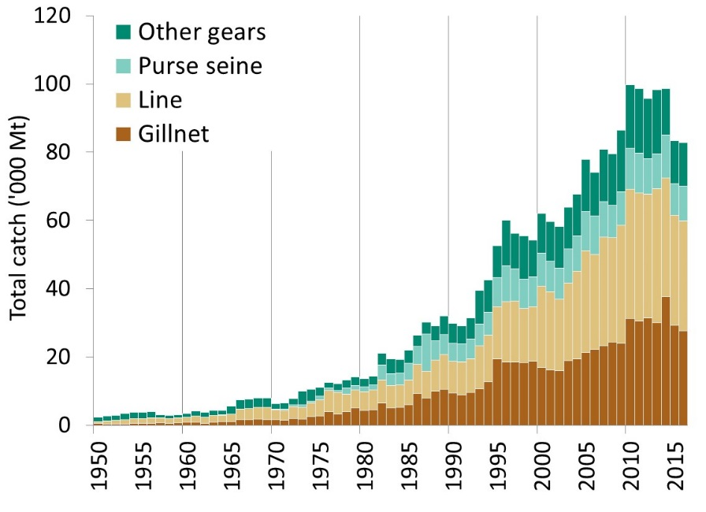
Fig. 1. Frigate tuna: Annual catches of frigate tuna by gear recorded in the IOTC Database (1950–2016).

Based on figures from the IOTC nominal catch database at the time of the WPNT07; June 2017.

