**Executive Summary: Shortfin Mako Shark**

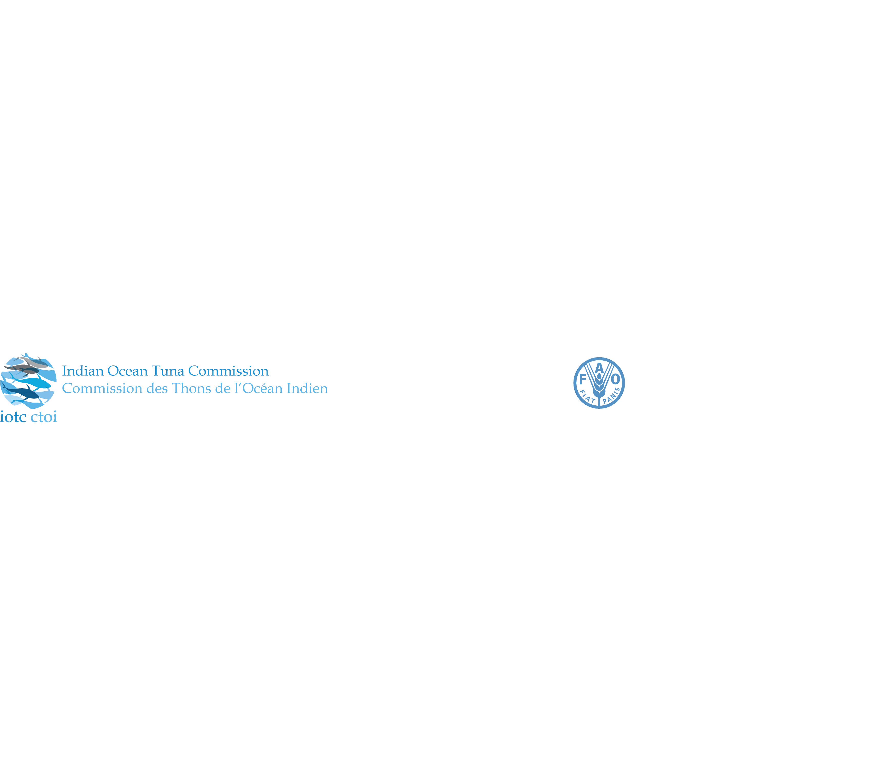

**Status of the Indian Ocean shortfin mako shark (SMA: *Isurus oxyrinchus*)**

**TABLE 1**. Shortfin mako shark: Status of shortfin mako shark (*Isurus oxyrinchus*) in the Indian Ocean.

|  |  |  |  |
| --- | --- | --- | --- |
| **Area1** | **Indicators** | | **2017 stock status determination** |
| Indian Ocean | Reported catch 2016:  Not elsewhere included (nei) sharks2 2016:  Average reported catch 2012-16:  Av. not elsewhere included (nei) sharks2 2012-16: | 1,631 t  54,495 t  1,503 t  49,152 t |  |
| MSY (1,000 t) (80% CI):  FMSY (80% CI):  SBMSY (1,000 t) (80% CI):  F2014/FMSY (80% CI):  SB2014/SBMSY (80% CI):  SB2014/SB0 (80% CI): | unknown |

1Boundaries for the Indian Ocean = IOTC area of competence

2Includes all other shark catches reported to the IOTC Secretariat, which may contain this species (i.e., SHK: sharks various nei; RSK: requiem sharks nei).

|  |  |  |
| --- | --- | --- |
| **Colour key** | Stock overfished(SByear/SBMSY< 1) | Stock not overfished (SByear/SBMSY≥ 1) |
| Stock subject to overfishing(Fyear/FMSY> 1) |  |  |
| Stock not subject to overfishing (Fyear/FMSY≤ 1) |  |  |
| Not assessed/Uncertain |  | |

**TABLE 2.**Shortfin mako shark: IUCN threat status of shortfin mako shark (*Isurus oxyrinchus*) in the Indian Ocean.

|  |  |  |  |  |
| --- | --- | --- | --- | --- |
| **Common name** | **Scientific name** | **IUCN threat status3** | | |
| **Global status** | **WIO** | **EIO** |
| Shortfin mako shark | *Isurus oxyrinchus* | Vulnerable | – | – |

IUCN = International Union for Conservation of Nature; WIO = Western Indian Ocean; EIO = Eastern Indian Ocean

3The process of the threat assessment from IUCN is independent from the IOTC and is presented for information purpose only

Sources: IUCN 2007, Cailliet 2009

**Indian Ocean stock – Management Advice**

***Stock status.*** There remains considerable uncertainty about the relationship between abundance, the standardised CPUE series, and total catches over the past decade (Table 1). The ecological risk assessment (ERA) conducted for the Indian Ocean by the WPEB and SC in 2012 (Murua et al., 2012) consisted of a semi-quantitative risk assessment analysis to evaluate the resilience of shark species to the impact of a given fishery, by combining the biological productivity of the species and its susceptibility to each fishing gear type. Shortfin mako sharks received the highest vulnerability ranking (No. 1) in the ERA rank for longline gear because it was characterised as one of the least productive shark species, and has a high susceptibility to longline gear. Shortfin mako sharks were estimated to be the third most vulnerable shark species in the ERA ranking for purse seine gear, but had lower levels of vulnerability than to longline gear, because of the lower susceptibility of the species to purse seine gear. The current IUCN threat status of ‘Vulnerable’ applies to shortfin mako sharks globally (Table 2). Trends in the Japanese standardised CPUE series from its longline fleet suggest that the biomass has declined from 1994 to 2003, and has been increasing since then. Trends in EU,Portugal longline standardised CPUE series suggest that the biomass has declined from 1999 to 2004, and has been increasing since then (see IOTC Supporting Information). There is a paucity of information available on this species, but this situation has been improving in recent years. Shortfin mako sharks are commonly taken by a range of fisheries in the Indian Ocean. Because of their life history characteristics – they are relatively long lived (over 30 years), females mature at 18–21 years, and have relativity few offspring (<25 pups every two or three years), the shortfin mako shark can be vulnerable to overfishing. There is no quantitative stock assessment currently available for shortfin mako shark in the Indian Ocean therefore the stock status is **uncertain**.

***Outlook.*** Maintaining or increasing effort can result in declines in biomass, productivity and CPUE. Piracy in the western Indian Ocean resulted in the displacement and subsequent concentration of a substantial portion of longline fishing effort into certain areas in the southern and eastern Indian Ocean. It is therefore unlikely that catch and effort on shortfin mako shark has declined in these areas, and may have resulted in localised depletion.

***Management advice.*** A precautionary approach to the management of shortfin mako shark should be considered by the Commission. Mechanisms need to be developed by the Commission to ensure CPCs comply with their recording and reporting requirement on sharks, so as to better inform scientific advice.

The following key points should also be noted:

* **Maximum Sustainable Yield (MSY)**: Unknown.
* **Reference points**: Not applicable.
* **Main fishing gear** (2012–16): Longline targeting swordfish; longline (deep-freezing); longline (targeting sharks); gillnet.
* **Main fleets** (2012–16): EU,Spain; South Africa; EU,Portugal; Japan, Iran, China ( Reported as discard : Australia, EU-France, Indonesia, Japan, Korea, South Africa)

**Literature Cited**

Murua H, Coelho, R., Santos, M.N., Arrizabalaga, H., Yokawa, K., Romanov, E., Zhu, J.F., Kim, Z.G., Back, P., Chavance, P., Delgado de Molina and Ruiz, J. (2012). Preliminary Ecological Risk Assessment (ERA) for shark species caught in fisheries managed by the Indian Ocean Tuna Commission (IOTC). IOTC–2012–SC15–INF10 Rev_1.