Executive Summary – Skipjack tuna
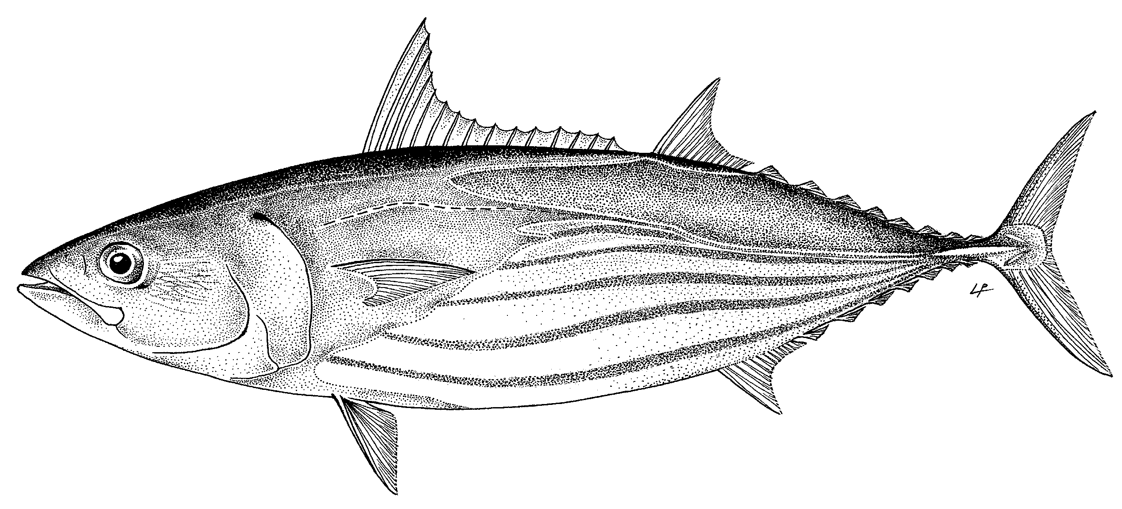

Status of the Indian Ocean skipjack tuna (SKJ: Katsuwonus pelamis) resource

TABLE 1. Skipjack tuna: Status of skipjack tuna (Katsuwonus pelamis) in the Indian Ocean.
Area¹ | Indicators |  | 2017 stock status determination
Indian Ocean | Catch 2016²:  Average catch 2012–2016: | 446,723 t  407,456 t | 47% *
 | Yield_{40%SSB} (1000 t) (80% CI):  E_{40%SSB} (80% CI):  C_{2016/}C_{40%SSB} (80% CI):  SB₂₀₁₆ (1000 t) (80% CI):  Total biomass B₂₀₁₆ (1000 t) (80% CI):  SB_{2016/}SB_{40%SSB} (80% CI):  SB₂₀₁₆/SB₀ (80% CI):  E_{40%SSB} (80% CI):  SB₀ (80% CI): | 510.1 (455.9–618.8)  0.59 (0.53–0.65)  0.88 (0.72-0.98)  796.66 (582.65-1,059.29)  910.4 (873.6-1195)  1.00 (0.88–1.17)  0.40 (0.35–0.47)  0.59 (0.53-0.65)  2,015,220 (1,651,230–2,296,135)
¹ Boundaries for the Indian Ocean stock assessment are defined as the IOTC area of competence.
² Proportion of catch estimated or partially estimated by IOTC Secretariat in 2016: 22%
* Estimated probability that the stock is in the respective quadrant of the Kobe plot (shown below), derived from the confidence intervals associated with the current stock status

Colour key | Stock overfished (SB_{year}/SB_{40%}< 1) | Stock not overfished (SB_{year}/SB_{40%}≥ 1)
Stock subject to overfishing(F_{year}/F_{40%}> 1) | 38% | 2%
Stock not subject to overfishing (F_{year}/F_{40%}≤ 1) | 13% | 47%
Not assessed/Uncertain

Indian Ocean stock – Management Advice
Stock status. A new assessment was carried out for skipjack tuna in 2017. The 2017 stock assessment model results differ substantively from the previous (2014 and 2011) assessments. The main reasons for this are: (i) the correction of an error in specifying selectivity for small fish in the previous assessments, (ii) the addition of tag-release mortality in the model and (iii) assuming effort creep of 1% per year since 1995 for the standardized European purse seine CPUE. The final overall estimate of stock status indicates that the stock is at the target biomass reference point and that the current and historical fishing mortality rates are estimated to be below the target. Over the history of the fishery, biomass has been well above and the fishing mortality has been well below the established limit reference points. The median value of Catch at the target fishing mortality (C_{SB40%})from the model runs investigated is 510,090 t with a range between 455,920 and 618,760t. Current spawning stock biomass relative to unexploited levels is estimated at 40% (Table 1). Catch in 2016 (≈446,723 t) remain lower than the estimated range of C_{SB40%} (Table 1). The average catch over the previous five years (2012–16; ≈ 407,450 t) also remains below the estimated range of C_{SB40%}. Thus, on the weight-of-evidence available in 2017, the skipjack tuna stock is determined to be not overfished and is not subject to overfishing (Table 1).
Outlook. Given the current status of the fishery and assuming that catch does not exceed prescription from Resolution 16-02, it would be expected that the stock would fluctuate around the target level. CPUE fluctuations, mainly for the purse seine, coincide with environmental signals at inter-annual timescale (e.g. Indian Ocean Dipole). Due to its specific life traits, skipjack can respond quickly to ambient foraging conditions driven by ocean productivity. Environmental indicators should be closely monitored to inform on the potential increase/decrease of stock productivity. There remains considerable uncertainty in the assessment, and the range of runs analysed illustrate a range of stock status to be between 0.35 and 0.47 of SB₂₀₁₆/SB₀ based on all runs examined.
Management advice. The catch limit will be calculated applying the Harvest Control Rule specified in Resolution 16-02.
The following key points should also be noted:
- Yield at the target fishing mortality The median (C_{SB40%}) value from the model runs investigated is 510,090 t with a range between 455,920 and 618,760 t (Table 1) In spite of the fact that the average catch between 2012–2016 (407,456) has been lower than the estimated C_{SB40%}, the stock has declined due to lower than expected recruitment in the recent period. It is unclear if recruitment will return to the expected levels in the near future. The stock appears to be in no immediate threat of breaching the limit reference point.
- Reference points: Noting that the Commission in 2016 agreed to Resolution 16/02 on harvest control rules for skipjack tuna in the IOTC area of competence, the following should be noted:
  - Fishing mortality: Current fishing mortality is considered to be below the target reference point of F_{SB40%}, and also below the limit reference point of F_{SB20%} (Fig. 2).
  - Biomass: Current spawning biomass is considered to be at the target reference point of 40% of SB₀, and above the limit reference point of 0.2*SB₀ (Fig. 2).

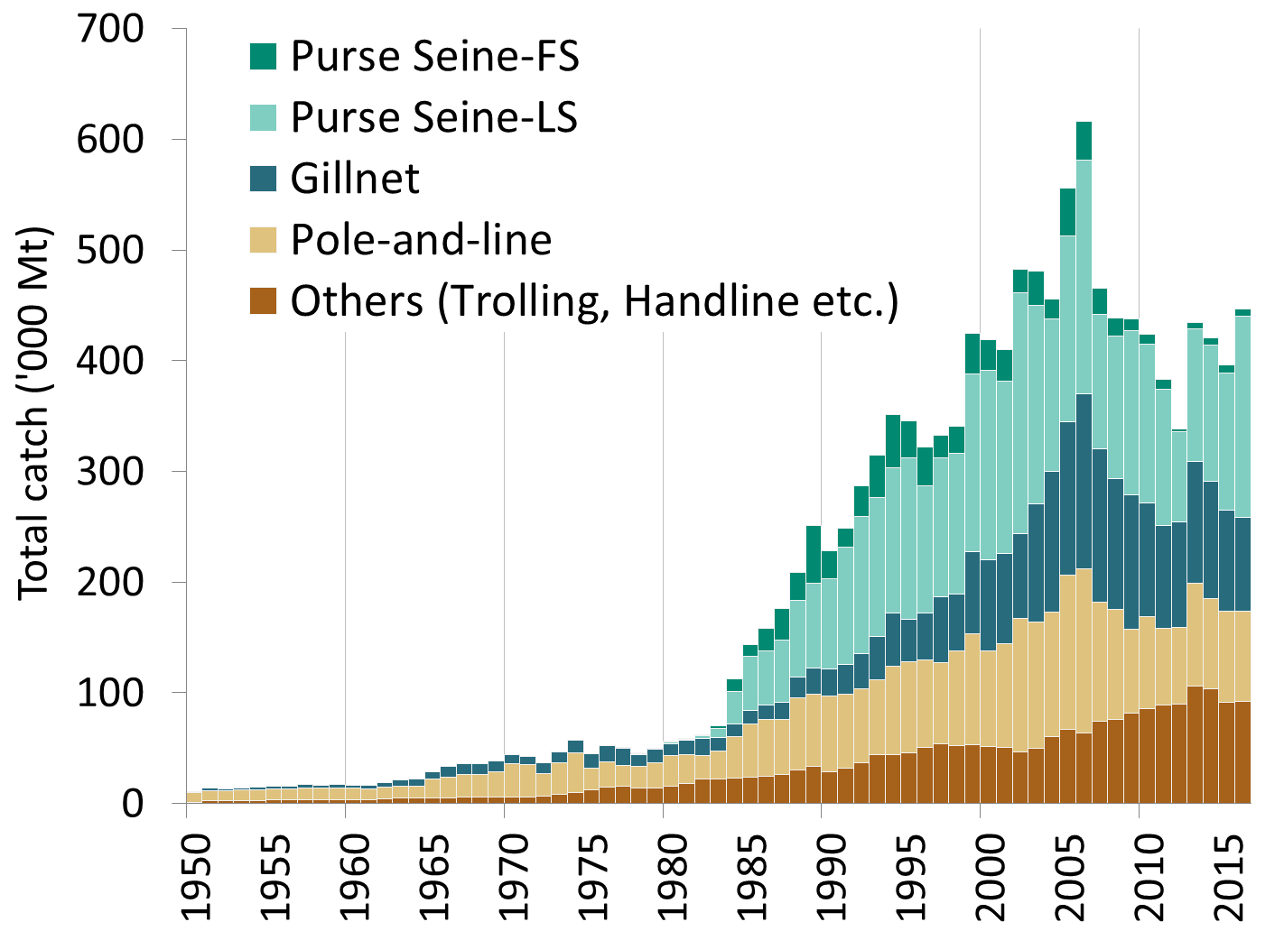

Fig. 1. Annual catches of skipjack tuna by gear (1950–2016).

Fig. 2. Skipjack tuna: SS3 Aggregated Indian Ocean assessment Kobe plot of the 2017 uncertainty grid. Black circles indicate the trajectory of the median estimates for the SB/SB_{target} ratio and E/E_{target} ratio across all models of the 2017 uncertainty grid for each year 1950–2016; grey dots are the estimates for year 2016 from individual models.

